Big Mountain Resort

# Introduction

Big Mountain Resort’s (BMR) has a new operational expense with the installation of the new lift, so we performed a pricing strategy review to cover the new cost evaluating the price elasticity to maximize the returns.

The relevance of all the facilities and the competitors’ pricing were taken into consideration while developing the new price strategy to increase the confidence in the correct pricing decisions and support future facility investment plans based on projected revenue.

# Data Wrangling

BMR was open 72 years ago in the region and state of Montana, with a total skiable terrain of 3,000 acres divided in 4 terrain parks. 600 avaible for night skiing and beyond the 333mm average snow fall, there are 600 acres are served by snow making. The peek is 6.817ft high and the base is at 4.464ft providing a vertical drop of 2.353ft. The lift facilities have 3 fast Quads, 2 Quads, 6 triples, and 3 surface, totaling 14 chairs for the 105 trails with the longest one running for 3.3 miles. Last year the resort was open for 123, and the same is expected for the current season.

Our target was the Adult Weekday Weekend price, currently at $81. The selection of the Weekend price considered xyz.

Analyzing the data of BMR and the competitors, it was missing just over 50% of fast eight information, 43% of night skiing and 15-16% of the ticket value. AdultWeekday is missing in a few more records than AdultWeekend.

We have two resorts called Crystal Mountain, however they are in different states. The resorts are distributed in 38 regions and 35 states. The majority in New York state. Our target is 13th, so we don’t have a high competion in the state.

By the ticket price distribution presented on the chart below we notice that BMR $81 ticket is the outlier for Montanta however it is reasonable price overall.

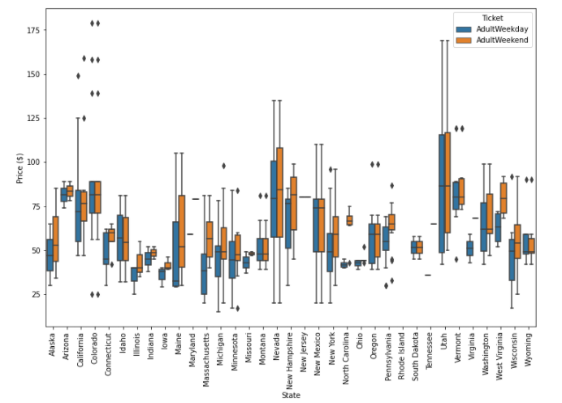

Target variable: AdultWeekday or AdultWeekend to be evaluated.

Resort information present without missing values.

Highlights:

330 rows, 27 columns. There are columns with null values. Columns: object (3), integer (11), and float (13).

Headers: existing and somehow comprehensible.

Missing data: most - fastEight 50%. Target data (price): 15-16% missing.

Missing Wildcard (for example, -1 and 999): not evaluated.

Categoricals Features:

One duplicate on the resort names, but considering the state name, this duplication disappeared.

Region and state have the same values on 297 rows, but 33 times they differed. Thus, the table has 38 distinct regions and 35 distinct states.

A bar graph showed the majority of resorts been located in New York. However, our resort is located in Montana.

Numbers as categoricals (0 and 1 as False and True): not checked.

Additions:

Data from the web imported and properly treated to validate the name of the states.

Others:

Dates: absent.

Visualization:

Histograms pre and post-outlier treatment.

Scatter plot of weekday price versus weekend price showcases a price variation concentrated on tickets below $100.

Cleansing:

Outliers fixed: possible typos during the data acquisition (YearsOpen).

Columns removed and rational:

fastEight: missing or zeros.

AdultWeekday:AdultWeekday and AdultWeekend have the same values for our resort, and AdultWeekday had more missing values.

Rows removed and rational:

NaN values from AdultWeekend - target variable, it can not be null.

No other adjustments were applied. There are variables with 20% of missing data. However, we will keep them for now.

Final output:

Treated data size: 277 rows, 25 columns.

1.13.0.2 Findings

Ticket price depends on geographical location and resort features.

# Exploratory Data Analysis

# Modeling

# Conclusion